Marketing Campaign Performance & Sales Analysis Report

1. Introduction
This project was completed as part of my internship to analyze marketing campaign data and understand how different advertising methods influence product sales. The main objective was to transform raw marketing data into meaningful insights using Excel and Power BI.
The project focuses not only on creating visuals, but also on understanding how data should be cleaned, structured, and transformed before analysis.

2. Project Objectives
The objectives of this project are:
- To convert raw marketing data into analysis-ready format
- To study the relationship between marketing spend and sales
- To identify high-performing advertising channels
- To evaluate cost efficiency
- To design a professional dashboard for business users
- To present insights in a clear and understandable way

3. Dataset Overview
The dataset contains information related to:
- Product Sold
- Traditional, Digital, Partnership, and Trust Spend
- Performance Channel
- Support Channel
- Cost Per Sale
- Total Spend
Initially, the dataset was not structured for direct business analysis. Therefore, several transformations were required.

4. Tools Used
- Microsoft Excel – Initial cleaning and understanding
- Power BI – Data modeling, DAX calculations, and dashboard design

5. Data Transformation & Preparation Process
Before analysis, the raw dataset was converted into analytical format. This was the most important stage of the project.
5.1 Data Type Correction
First, all columns were checked for correct data types.
- Product_Sold → Converted to Whole Number
- Spend Columns → Converted to Decimal Number
- Category Columns → Converted to Text
This step was required to avoid calculation and DAX errors.
5.2 Grouping Spend Methods into Categories
The original dataset contained multiple spend methods. For better analysis, they were grouped into four main categories:
Category | Methods Included
Traditional | TV, Billboard
Digital | Google Ads, Social Media
Partnership | Affiliate marketing
Trust | Influencer marketing

Why This Was Done:
- Raw methods were too detailed for strategic analysis
- Businesses usually evaluate at category level
- Helps compare major marketing strategies
This grouping simplified the dataset and improved decision-making relevance.
5.3 Grouping Categories into Channels
Next, categories were grouped into two channels:
Channel Type | Categories
Performance Channel | Traditional, Digital
Support Channel | Partnership, Trust

Why This Was Done:
- Performance channels directly drive sales
- Support channels assist indirectly
- Helps compare core vs supporting marketing efforts
This made it easier to analyze campaign structure.
5.4 Creating Product Sold Ranges (Buckets)
To understand sales patterns, Product_Sold was converted into ranges:
Range Name | Values
0–5000 | Low Sales
5000–7000 | Medium-Low
7000–9000 | Medium-High
9000+ | High Sales

Why Buckets Were Created:
- Raw numbers are difficult to compare visually
- Buckets show growth stages
- Helps analyze performance at different business levels
Why These Ranges Were Selected:
- Based on data distribution
- Balanced number of records
- Avoided extreme imbalance
- Covered business-relevant sales levels
5.5 Creating Bucket Order Column
Since ranges are text, Power BI sorts them alphabetically.
So a Bucket Order column was created:
Range | Order
0–5000 | 1
5000–7000 | 2
7000–9000 | 3
9000+ | 4

This was used to sort visuals correctly.
5.6 Calculating Total Spend
Total Spend was calculated as:
- Total Spend = Traditional + Digital + Partnership + Trust
Why:
- To know overall marketing investment
- Used for KPI and ROI analysis
- Required for management reporting
5.7 Calculating Cost Per Sale
Cost Per Sale was calculated as:
- Cost Per Sale = Total Spend / Product Sold

Why This Was Important:
- Shows efficiency of marketing
- Measures how much is spent to sell one unit
- Helps compare campaigns fairly
- Used to evaluate ROI indirectly
Without this metric, efficiency cannot be measured.
5.8 Why Averages Were Used Instead of Totals
In many visuals, Average Spend was used instead of Total Spend.
Reason:
The dataset has uneven bucket sizes.
Example:
- 0–5000 → ~35 records
- 5000–7000 → ~109 records
- 7000–9000 → ~125 records
- 9000+ → ~31 records
If totals were used:
- Buckets with more records would automatically look better.
This creates misleading insights.
Using averages:
- Removes record count bias
- Allows fair comparison
- Shows true performance
Therefore, averages were preferred.

6. Exploratory Data Analysis (EDA)
After transformation, EDA was performed.
Activities:
- Analyzed spend vs sales
- Compared categories across buckets
- Studied cost efficiency
- Checked distribution patterns
- Verified channel performance
EDA helped validate assumptions before visualization.

7. Dashboard Design & Structure
The dashboard was designed on a single page for easy understanding.
7.1 KPI Section
Top-left cards show:
- Total Marketing Spend
- Average Cost Per Sale
- Total Units Sold
Purpose: Quick performance snapshot.
7.2 Main Visual Section
Visual | Purpose
Donut Chart | Category spend share
Bar Chart | Category vs sales range
Combo Chart | Channel comparison
Column Chart | Cost efficiency
Table | Detailed spend summary

Each visual answers a specific business question.
7.3 Dashboard Placement
After analysis, the final dashboard is inserted in the report to visually support findings.
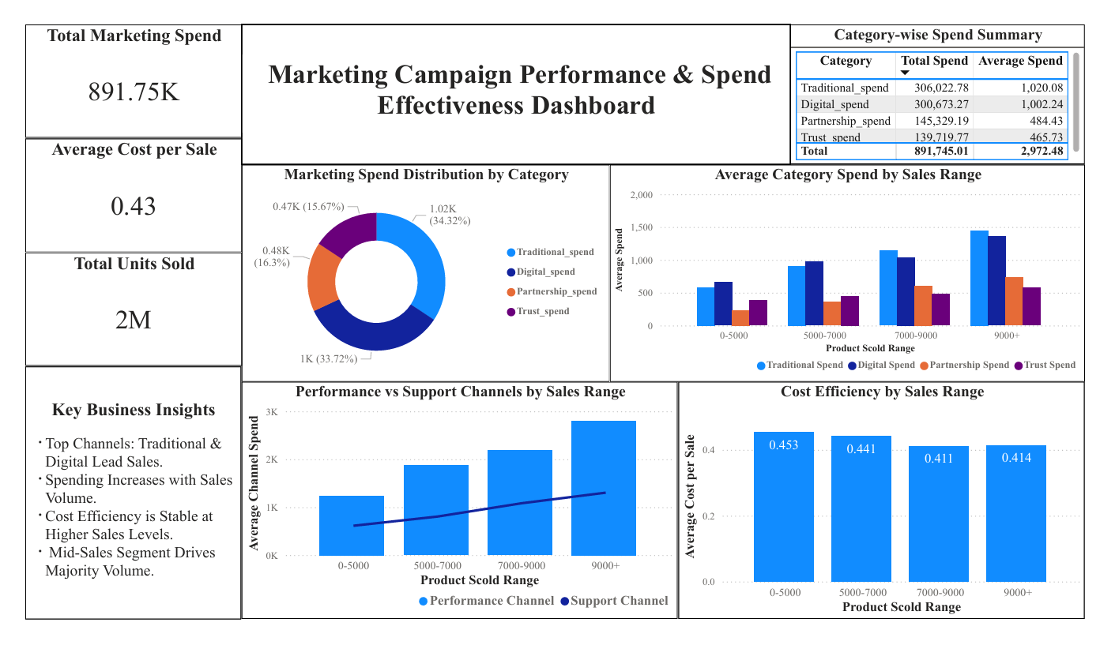
The dashboard was placed after analysis to visually represent the key findings and support business decision-making.

8. Key Business Insights
- Traditional and Digital channels generate highest sales
- Higher sales require higher investment
- Cost per sale remains stable at high volumes
- Mid-sales segment (5000–9000) drives majority revenue
- Support channels need optimization

9. Business Recommendations
- Increase investment in Traditional & Digital
- Improve efficiency of Trust & Partnership
- Focus on mid-sales growth segment
- Track cost per sale regularly
- Reallocate underperforming budgets

10. Challenges Faced
- DAX syntax errors
- Circular dependency issues
- Sorting problems
- Data imbalance
- Understanding business logic
These improved my problem-solving skills.

11. Learning Outcomes
Through this project, I learned:
- Data transformation techniques
- Power BI modeling
- DAX calculations
- Business-oriented analysis
- Dashboard storytelling

12. Conclusion
This project demonstrates how raw marketing data can be transformed into meaningful business insights through systematic preprocessing, analysis, and visualization.
By grouping data, creating meaningful metrics, and using appropriate aggregations, a decision-support dashboard was developed. This project has helped me improve both my technical and analytical skills.

